Addenda to US Space Cover Collecting Handbook
From Ray E . Cartier

Dr. Ross Smith of Australia has done extensive research on Secondary Recovery Ships, Tracking Ships and Tracking Stations since the information that I had used was first created. As a result he has sent me additional information and corrections to my handbook, based on his website, http://recovery_ships.rossjsmith.com .
Page Corrections
109 GT-3 Beck “Crew Covers”. Dr. Smith states that he believes that Morris Beck gave a number (probably 25) to the Postal Clerk aboard all PRS and SRS for all Gemini, Apollo, Skylab and ASTP missions.
111 GT-6 is also known to some as Gemini 6A. (Note: I used what is shown on the covers to avoid confusion)
115 The Gemini 6 scrubbed cover is extremely rare and rates at least a 5. (It is now listed as 6 / $100 - $150)
116 Captain’s covers for Gemini 7, 9, 11, and 12 were inadvertently left out of the table.
GT-7 Same Captain Cover 5 / $40 - $80
GTA-9 Same Captain Cover 5 / $40 - $80
GTA-11 Same Captain Cover 5 / $40 - $80
GTA-12 Same Captain Cover 5 / $40 - $80
116-17 No evidence that the Croatan, Twin Falls or Longview were involved in any Gemini mission.
117 GT-5 The Dupont is misspelled as Cupont. CVSG 54 is an aircraft squadron & not a ship.
117 GTA-a6 (Scrubbed). The Aewron does not exist. Ausilla should read Aucilla. CVSG-52 is an aircraft squad-
ron and is also listed on GT-6 and GT-7.
117 Add ships: Cochrane, George K. MacKenzie and Hassayampa. VP-16 is not a ship.
117 GTA-9, 10, 11 and 12. HS 3, HS 11, and VC49 are not ships. Add the Severn to GTA-11
Tracking ships can be found at his above website.
He suggested that I show the following three covers which can be placed at the base of page 111.
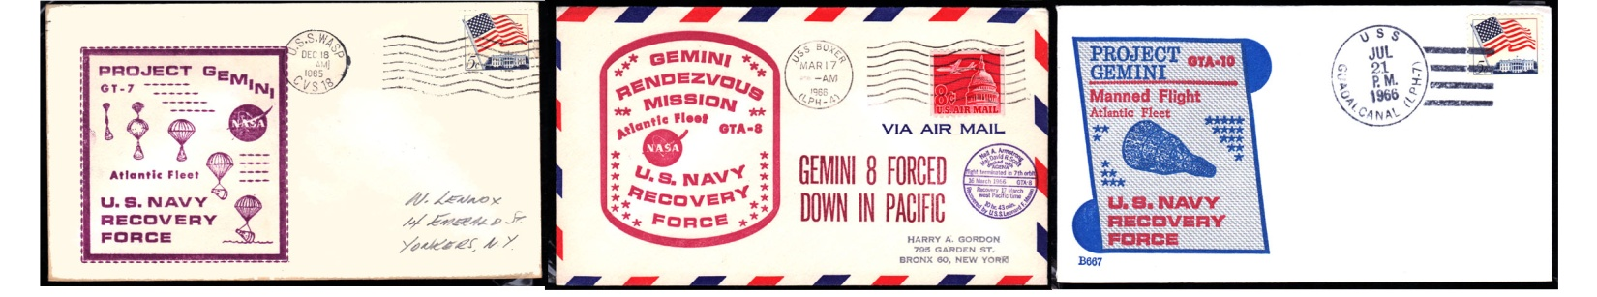
3 / $8 - $12 GT-7 NRSC. USS Wasp 4 / $12 - $18 Apparently printed cachet 4 / $15 - $25 GTA-10 Beck cachet.
addressed to Harry Gordon. Unusual USS Guadalcanal
USS Boxer – GTA-8
Australian Tracking Stations for Gemini: Red Lake, Woomera and later Carnarvon. Canberra (Honeysuckle Creek and Tidbinbilla) were not used until Apollo.
128 AS-201 was not referred to as Apollo 1. HS-5 is not a ship.
128 AS-203 was not referred to as Apollo 2.
129 AS-202 was not referred to as Apollo 3. Range Tracker was not involved.
129 Apollo 4. The Arnold and Twin Falls were not involved.
129 Apollo 5. The Twin Falls was not involved but the Watertown was.
129 Apollo 6. The Twin Falls was not involved but the Range Tracker may have been.
129 Apollo 7 The Rushmore and Hassayampa were not involved.
130 Apollo 8 The Guadalcanal was involved.
132 Apollo 11 The Mercury was involved. It is shown twice. Delete the entry under “not involved”.
133 Apollo 12 The Escape was assigned.
133 Apollo 12-17. The only tracking ship involved was the Vanguard.
133 Apollo 13. There were 10 US and 7 international ships assigned, plus the Vanguard as Tracking.
135 Apollo 15 The Salinan was an SRS and not a Tracking ship.
135 Apollo 16. The Opportune wan an SRS and not a Tracking Ship.
148 Bottom left cover shown for ASTP is not as described. (Note: Correction shown on next page at top).
Prices are the same as shown in the book. I had just input a different Return to Port cover as the first one.

Charles Bromser, the F.I.P. representative from Australia also had comments:
Page 23 would have better showing an example of a type 6 cover, such as a rare Schmiedl, the 1934 Geman cover shown is lacking evidence of postal use. (Note: I shouldn’t have shown the center top Hexentanzplatz cover at all as this is a US Space Cover Catalog).
Page 61 Avoid recommendations that stamp errors are a part of Astrophilately. The Viking flights have relevant covers hence stamps are not needed. (Note: I showed this as on Page 191 of my book, the F.I.P. Guidelines for Judging, reads in 3.2.1 “The exhibit may also include varieties of stamps such as perforation, error in colour, overprints as well as essays and proofs.” Thus far no US Judges have brought up the use of two stamps in my current exhibit shown at five different shows to 20 different judges. However, F.I.P. runs the International Show to be held in New York in 2016 and their rules and judges are stricter.)
Page 196. Presentation: It would be best to note that judges see presentation as an indicator for the exhibit as a whole. Often a sloppy presentation indicates sloppy “treatment”. Avoid using the word “importance” (on this page in the first sentence) since there could be confusion with the actual “importance” criterion. Also, today large covers (#10) are best placed on double pages. Many European/Australian exhibitors use A3 pages. At the top level the 5 points are a must in this area. (Some, but not most, judges do not like #10 envelopes cocked at an angle on a sheet. Most let this one pass).
Page 200 I would prefer not to see two pages for the Title/Introduction. Good exhibitors are able to get this down to a single page. The downside of a content page is that it often highlights the imbalances of an exhibit i.e. a lack of early items or over-emphasis of tracking covers etc. (Note: I’ve never heard this mentioned in any US critique that I have been to. On the contrary, I have heard several judges comment on the need for a content page. These comments are passed along as they do matter at F.I.P. shows. However, judges have told me that they do not use F.I.P. rules here, but do use the APS Manual of Philatelic Judging. This is good information to know, however.)

Changes that I have found and am adding.
Page 22 at the bottom
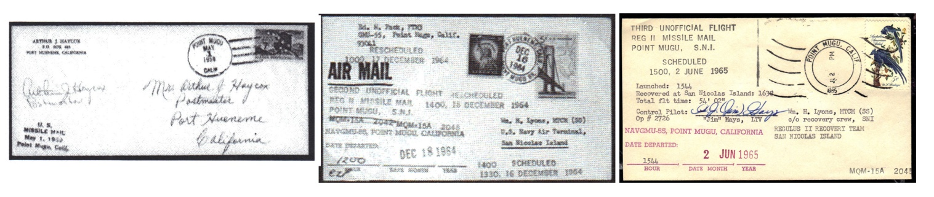
5 / $3500 - $5000. Point Mugu, California 6 / $1,500 - $3,000 Flown on Regulus II 6 / $1,500 - $3,000 Flown on Regulus II
5/1/59. Cover says Missile Mail EZ Cat. Drone. Only 5 carried 12/18/64 Drone. Estimated only 5 flown. 6/2/65
#24C1 says 137 flown 2nd Unofficial Flight. Value shown may be low 3rd Unofficial Flight. Value shown may be low.

Have also recently seen a Regulus II flown cover (1 of 9) from Venice, Florida. Estimate is the same as the last two covers above.
Page 33 Change HAM flight at bottom of page to show 4 / $100 - $150
Page 34 add-on above Scatback
ENOS, a chimpanzee was successfully recovered after orbiting the Earth. 29 Nov 1961 4 / $60 - $100

Page 47. Discoverer Series. Adding-on recovery dates plus other corrections:
- 11 Aug 1960 Recovered at sea by frogmen 5 / $60 - $80
15 15 Sep 1960 Splashed down. Capsule sank. Couldn’t recover NKC
17 14 Nov 1960 Capsule snagged in mid-air by C-119 aircraft 5 / $35 - $50
19 20 Dec 1960 USS Escape c/o Fleet PO, NY, NY 6 / $50 - $100
25 19 Jun 1961 Recovery of Data Capsule 4 / $40 - $55
26 10 Jul 1961 Midair Recovery made 4 / $40 - $55
29 2 Sep 1961 Mid-Air Recovery 4 / $40 - $55
30 4 Sep 1961 Mid Air Recovery 4 / $40 - $55
32 13 Oct1961 Launch. Radiation damage to several metals 4 / $25 - $40
32 16 Oct 1961 Capsule recovered. 96% of film out of focus 4 / $30 - $45
35 16 Nov 1961 Recovered capsule 4 / $30 - $45
36 17 Dec 1961 Data capsule recovered 4 / $30 - $45
38 27 Feb 1962 Last firing in this series 4 / $25 - $40
38 3 Mar 1962 Recovered. 1st mission KH-4 camera. Out of focus. 4 / $30 - $45
Delete Discoverer 39 from last listing I reviewed. Advise if you know differently.

Page 94 Mercury-Redstone 1A (MR-1A) Correct the typo error in the date from 9 December to 19 December.
Page 94 Change Goliath on Mercury-Atlas 32E to show 5 / $200 - $300
Page 148 Replace the image of the cover in the lower left corner with this ASTP “Day-After” image.
Page 166 I inadvertently left out this image of the Apollo 6 KSC Official in editing. It can fit at the bottom.

